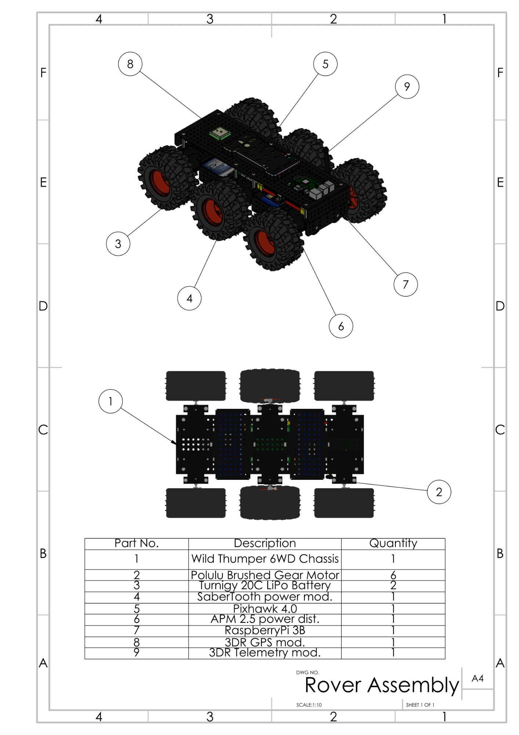

W

Part No.

Quantity

Description Wild Thumper 6WD Chassis Polulu Brushed Gear Motor

Turnigy 20C LiPo Battery Sabertooth power mod.

Pixhawk 4.0 APM 2.5 power dist. Raspberry Pi 3B

3DR GPS mod. 3DR Telemetry mod.

DWG NO.

Rover Assembly A

A4

SCALE:1:10

SHEET 1 OF 1